

***INSTITUTE OF INFORMATION TECHNOLOGY***

***JAHANGIRNAGAR UNIVERSITY***

**Number of Assignment :** 01

**Submission Date :** 07/01/2023

**Course Tittle :** Software Engineering

**Course Code :** ICT - 3201

**Submitted To Submitted By**

Fahima Tabassum Md. Shakil Hossain

Professor Roll – 2023

IIT – JU 3nd year 2nd Semester

IIT – JU

**User Stories:**

1. **User Story 1:** As a student, I want to be able to log into the online learning platform so that I can access my course materials and assignments.
2. **User Story 2:** As a student, I want to be able to submit my assignments online and receive feedback from my instructor, so that I can improve my understanding of the course material.

**Flow of Events:**

1. The student opens the online learning platform and clicks on the "Log In" button.
2. The platform displays the login form.
3. The student enters their username and password.
4. The platform verifies the student's credentials and logs them in.
5. The student navigates to the course page and clicks on the assignment submission link.
6. The platform displays the assignment submission form.
7. The student uploads their completed assignment and clicks on the "Submit" button.
8. The platform confirms that the assignment was received and sends a notification to the instructor.
9. The instructor reviews the assignment and provides feedback to the student through the platform.

**Online Learning Platform Use Case Diagram:**

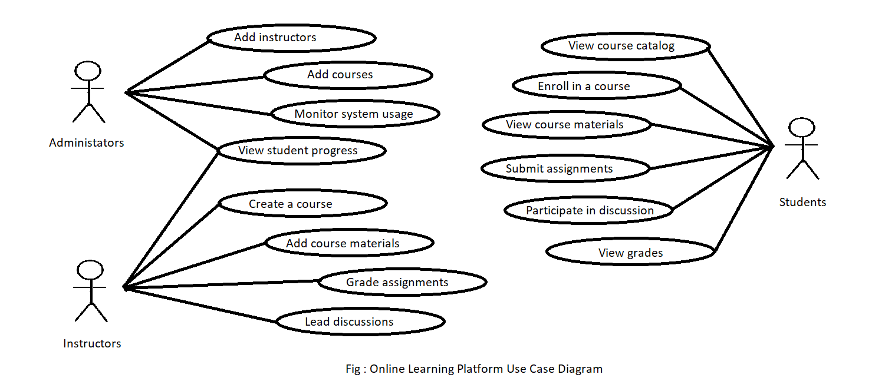

An online learning platform use case diagram is a visual representation of the interactions between actors and the system in the context of an online learning platform. The actors in this context are typically students, instructors, and administrators.

Here is an example of a simple use case diagram for an online learning platform:

Students:

* View course catalog
* Enroll in a course
* View course materials
* Submit assignments
* Participate in discussions
* View grades

Instructors:

* Create a course
* Add course materials
* Grade assignments
* Lead discussions
* View student progress

Administrators:

* Add instructors
* Add courses
* View student progress
* Monitor system usage

**System:** Online Learning Platform

Use Case 1: View Course Catalog

* Description: Students can browse a catalog of available courses and view course descriptions, objectives, and requirements.

Use Case 2: Enroll in a Course

* Description: Students can select and enroll in a course. The system will check if the student meets the prerequisites and has available slots in their schedule. If the enrollment is successful, the system will add the course to the student's list of enrolled courses.

Use Case 3: View Course Materials

* Description: Students can view the course materials, such as lectures, readings, and assignments, for their enrolled courses.

Use Case 4: Submit Assignments

* Description: Students can submit assignments for their enrolled courses. The system will check that the submission is on time and meets any requirements specified by the instructor.

Use Case 5: Participate in Discussions

* Description: Students can participate in online discussions with their classmates and instructors for their enrolled courses.

Use Case 6: View Grades

* Description: Students can view their grades and feedback for their enrolled courses.

Use Case 7: Create a Course

* Description: Instructors can create new courses and specify the course materials, objectives, and requirements.

Use Case 8: Add Course Materials

* Description: Instructors can add or update course materials, such as lectures, readings, and assignments, for their courses.

Use Case 9: Grade Assignments

* Description: Instructors can review and grade student submissions for their courses.

Use Case 10: Lead Discussions

* Description: Instructors can lead and participate in online discussions with their students for their courses.

Use Case 11: View Student Progress

* Description: Instructors can view the progress of their students in their courses, including grades and participation in discussions.

Use Case 12: Add Instructors

* Description: Administrators can add new instructors to the system and assign them to teach specific courses.

Use Case 13: Add Courses

* Description: Administrators can add new courses to the system and assign instructors to teach them.

Use Case 14: Monitor System Usage

* Description: Administrators can monitor the usage of the online learning platform, including the number of active users and the usage of specific features.

**Architectural Design:**

There are many different architectural designs that could be appropriate for an online learning platform, and the specific design will depend on the specific requirements and constraints of the platform. Here is an example of an architectural design for an online learning platform:

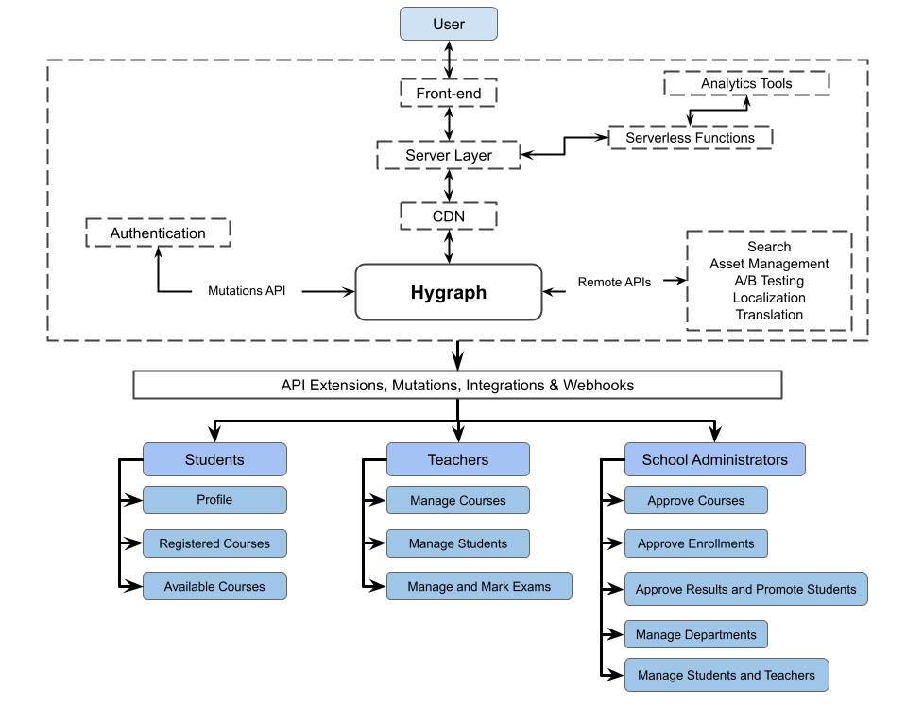

1. Client-Server Architecture: The platform will use a client-server architecture, with the client being a web application accessed through a browser and the server being a set of servers that host the web application and store data.
2. Load Balancer: A load balancer will be used to distribute incoming traffic to the web servers and ensure that the system can handle high levels of traffic.
3. Web Servers: The web servers will host the web application and serve web pages to users. They will also handle user requests and communicate with the database servers to retrieve and store data.
4. Database Servers: The database servers will store the data for the platform, including user profiles, course information, and assignment submissions.
5. Storage: Large files, such as videos and other course materials, will be stored on a distributed storage system, such as Amazon S3, to ensure that they can be accessed quickly and reliably.
6. Content Delivery Network (CDN): A CDN will be used to deliver static content, such as images and videos, to users from servers located near the user's location, to improve the performance of the platform.
7. Monitoring: The platform will use monitoring tools to track the performance and availability of the system and alert the administrators if there are any issues.
8. Security: The platform will use various security measures, such as encryption and authentication, to protect the confidentiality and integrity of the data and the system.